EFFECTIVE STRATEGIES
1. Show students how to hold a pencil.
2. Model efficient and legible letter formation.
3. Provide multiple opportunities for students
to practice effective letter formation.
4. Use scaffolds, such as letters with numbered
arrows showing the order and direction of strokes.
5. Have students practice writing letters from
memory.
6. Provide handwriting fluency practice to build
students’ automaticity.
7. Practice handwriting in short sessions.

Referenced in 2021 Dyslexia Handbook
—Adapted from Berninger et al., 1997; Berninger et al., 2006; Denton, Cope, & Moser, 2006; Graham et al., 2012; Graham, Harris, & Fink, 2000; Graham & Weintrub, 1996.

POSSIBLE ACCOMMODATIONS
TO BE DETERMINED BY
COMMITTEE
∙ Copies of notes (e.g., teacher- or peer provided)
∙ Note-taking assistance
∙ Additional time on class assignments and tests
∙ Reduced/shortened assignments (e.g., chunking
assignments into manageable units, fewer
items given on a classroom test or
homework assignment without eliminating
concepts, or student planner to assist with
assignments)
∙ Alternative test location that provides a quiet
environment and reduces distractions
∙ Priority seating assignment
∙ Word banks
∙ Electronic spellers
∙ Electronic dictionaries
∙ Adaptive learning tools and features in software programs

Resources for State Testing Accommodations:
https://tea.texas.gov/student-assessment/testing/student-assessment-overview/accommodation-resources
Contacts for Further Information
State Dyslexia & Related Disorders Consultant Region 10 Education Service Center 400 E. Spring Valley Road Richardson, TX 75083-1300 Texas Dyslexia Hotline: 1(800) 232-3030
www.region10.org/dyslexia/index

Dyslexia & Related Disorders contacts at the Texas Regional Education Service Centers http:www.tea.state.tx.us/regional_services/esc/

The Dyslexia Handbook, 2021 (pages 60-73)
https://tea.texas.gov/academics/dyslexia/

District/Campus Dysgraphia Contact:
Hughes Springs ISD Curriculum and Special Programs Director 903-639-3810

Parent Resources:
https://www.dysgraphia.life/resources

https://www.lwtears.com/freeresources

https://www.understood.org/articles/how-to-help-your-child-with-writing

IDEA/504/RtI
Response to Intervention: a multistep, or tiered, approach to providing services and interventions at increasing levels of intensity to students who struggle with learning
Section 504: provides equal opportunity eligible students with disabilities when compared to their non-disabled peers. Provides support and interventions through general education.
IDEA: ensures that all children with disabilities have available to them a free appropriate public education. Provides individual supplemental educational services and supports in addition to what is provided to students in the general curriculum to ensure that the child has access to and benefits from the general curriculum.

Dysgraphia Program
Awareness for
Educators and
Parents

HUGHES SPRINGS
ISD

What is dysgraphia?

How do we assess and
identify for dysgraphia?

What are effective strategies
for students with dysgraphia?

Who delivers instruction for
students with dysgraphia?

What accommodations are
available for students with
dysgraphia?

What is the difference
between IDEA, Section 504
and RtI?

Who do I contact for
information or concerns?
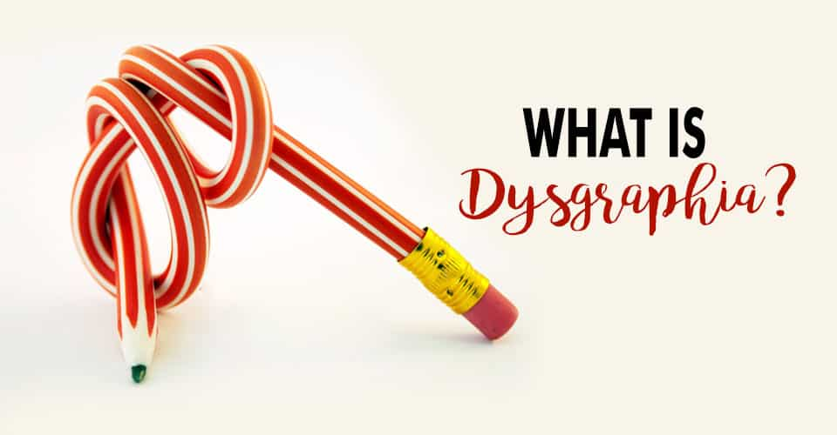

WHAT IS DYSGRAPHIA?

A review of recent evidence indicates that dysgraphia is best defined as a neurodevelopmental disorder manifested by illegible and/or inefficient handwriting due to difficulty with letter formation. This difficulty is the result of deficits in graphomotor function (hand movements used for writing) and/or storing and retrieving orthographic codes (letter forms) (Berninger, 2015). Secondary consequences may include problems with spelling and written expression. The difficulty is not solely due to lack of instruction and is not associated with other developmental or neurological conditions that involve motor impairment.

Referenced in 2021 Dyslexia Handbook

HOW IS DYSGRAPHIA ASSESSED
FOR AND IDENTIFIED?

The law that applies to an individual student is
determined by data and the student’s individual needs.
If a team determines that the data lead to the
suspicion of a disability, the team must refer the student
for an evaluation under IDEA. If a student is suspected of
having a disability and the determination is made to
evaluate through IDEA, all special education
procedures must be followed.

Students enrolling in public schools in
Texas must be assessed for dyslexia and related
disorders “at appropriate times” (TEC §38.003(a)).

When formal evaluation is recommended, the school
must complete the evaluation process as outlined in
IDEA. Procedural safeguards under IDEA must be followed.
Formal evaluations would assess the academic skills and
cognitive processes related to dysgraphia. Decisions should
be made by the ARD committee.

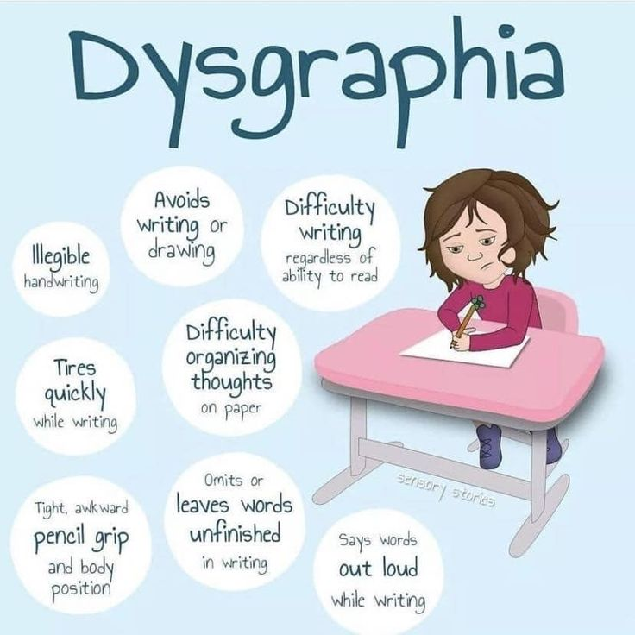

QUESTIONS FOR DETERMINING
DYSGRAPHIA:

1. Do the data show the following characteristics and consequences of dysgraphia?
• Illegible and/or inefficient handwriting with variably shaped and poorly formed letters Difficulty with unedited written spelling
• Low volume of written output as well as problems with other aspects of written expression
2. Do these difficulties (typically) result from a deficit in graphomotor function (hand movements used for writing) and/or storing and retrieving orthographic codes (letter forms)?
3. Are these difficulties unexpected for the student’s age in relation to the student’s other abilities and the provision of effective classroom instruction?

WHO DELIVERS INSTRUCTION?
A certified teacher who has been trained in dyslexia and
related disorders and the curriculum of instruction the district has developed or purchased for use with students with dyslexia as well as in instructional strategies that utilize individualized, intensive, multisensory, phonetic methods.

